Trade of Metal Fabrication
Module 1: | Basic Fabrication
Unit 5: | Introduction to Machinery
 | Phase 2

Table of Contents
List of Figures 5
List of Tables 5
Document Release History 6
Module 1 – Basic Fabrication 7
Unit 5 – Introduction to Machinery 7
Learning Outcome: 7
Key Learning Points: 7
Training Resources: 7
Key Learning Points Code: 7
Shear Tooling – General Guides 8
Hydraulic System 9
Cleaning 9
Section Tooling – General Guides 9
Plane Figures 10
Triangles 10
Squares and Rectangles 10
Parallelogram 10
Angles 11
Setting Out Angles With and Without a Protractor 11
Hexagons 12
Exercises 13
Octagons (Eight-Sided Figures) 14
Circles 14
Material Removal 15
Shearing (Guillotine) 15
Shears 16
Guillotine – Steel Stores 17
Safe Work Practices 17
Objective: 17
Personal Protective Equipment: 17
Procedure: 17
Safety Issues 17
Metal Working Machines 18
Objective 18
Personal Protection 18
Procedure 18
Safety Issues 18
Shearing (Guillotine) 19
The Guillotine 19
Blade Clearance 19
Rake Angle 19
Relief Angle 19
The Blades 19
Guillotines 19
Safety 20
The Principle of Shearing 20
Self Assessment 21
Questions on Background Notes – Module 1.Unit 5 21
Answers to Questions 1-10. Module 1.Unit 5 24
Index 27

List of Figures
Figure 1 - Shear Tooling 8
Figure 2 - Guillotine: Principle of Shearing 15
Figure 3 - One Straight Fixed Blade, One Rotating Circular Blade 16
Figure 4 - Two Rotating Circular Blades, One at an Angle to the Other 16

List of Tables

Document Release History
Date | Version | Comments
11/08/06 | First draft
13/12/13 | SOLAS transfer

Module 1 – Basic Fabrication

Unit 5 – Introduction to Machinery
Duration – 7 Hours

Learning Outcome:
By the end of this unit each apprentice will be able to:
- Safely set up and operate the guillotine
- Relate advantages of the back stop
- Identify location of all emergency stop buttons

Key Learning Points:
Rk | - Principles of shearing  - Chip forming – Non chip forming (methods)  - Types of shearing equipment  - Material selection
Sk | Correct use and operation – blade clearance – back stop – guards.
H | Safety precautions and procedures.
M | Surface areas of plain figures.
Rk | Machine maintenance.
P | Communication skills, Quality awareness.

Training Resources:
Std. fabrication workshop, Guillotine. Handouts – Apprentice Toolkit. P.P.E.

Key Learning Points Code:
M = Maths D= Drawing RK = Related Knowledge Sc = Science
P = Personal Skills Sk = Skill H = Hazards

Shear Tooling – General Guides
- The quality of the cut is an immediate indication of the condition of the blades.
- Ensure hold-down is always set for relevant thickness of material being sheared. DO NOT allow ends of bars to be fed beyond the hold down, because bar would tend to twist between blades and cause body distortion.
- Always feed material between blades from the hold down side.
- Keep the blade area clean. Do not allow 'build up' of mill scale.
- Stay within the rated capacity of the machine.

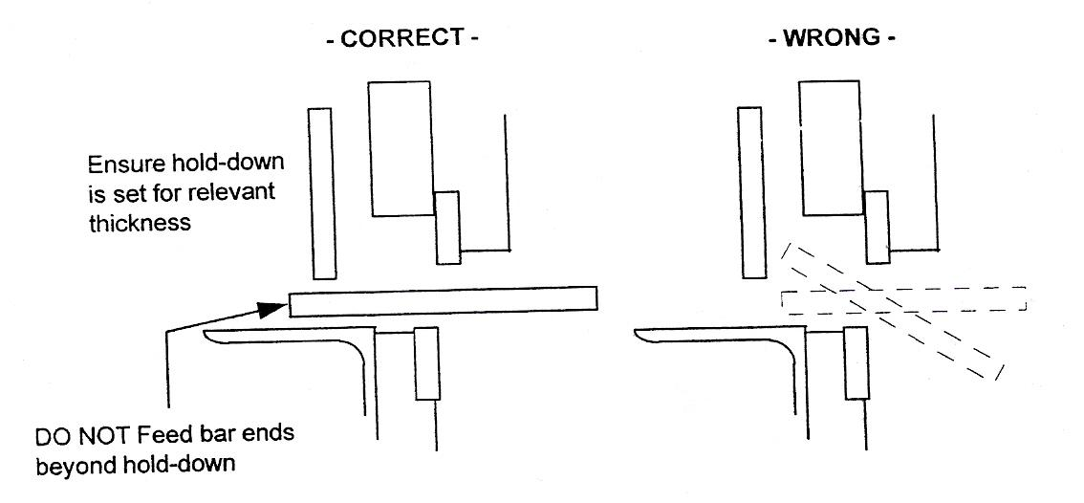
Figure 1 - Shear Tooling

Hydraulic System
A 3kW Motor drives a hydraulic pump, which through control valves feed the power cylinder of the machine. The cylinder is connected to a pivoted arm.
Hydraulic Oil - refer to the recommended oils label. The oil filler/breather is positioned on the tank accessible by removing the louvered cover at base of the machine.
Suction Strainer - inspect oil strainer every twelve months. The strainer is accessible, having released the screws in tank cover, if necessary wash in paraffin (Replacement L820/5020).
Sludge Tray - whilst lower cover is removed, check tray located under main frame once every twelve months.

Cleaning
Under normal operation, all visible working parts should be regularly cleaned of foreign matter, thus preventing excessive wear and possible failure.

Section Tooling – General Guides
- The quality of the cut is an immediate indication of the condition of the blades. Keep sharp, keen cutting edges.
- Ensure bar sizes are used in smallest aperture that will accept them, ensuring well supported cut.
- Always feed material between blades from hold down side.
- Keep cutting aperture clean, small slivers, short ends and any other pieces should be removed from the blade area. DO NOT allow mill scale to 'build up' in the blade area.
- Stay within the rated capacity of the machine.

Plane Figures

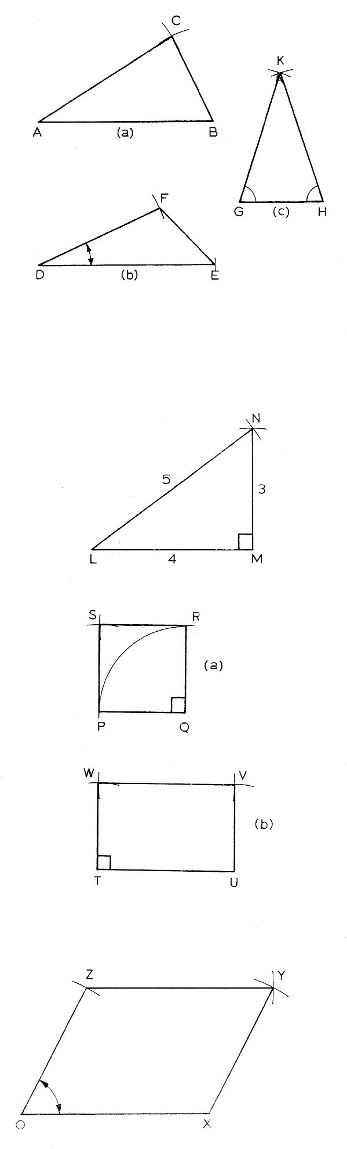
Triangles
Scalene – (a) and (b) in top illustration.
(a) With the lengths of the sides given:
Draw AB.
Centre A, draw an arc, radius = AC.
Centre B, draw ail arc, radius = BC.
Join A to C, and join B to C.
(b) With two sides and included angle given:
Draw DE.
Mark off angle EDF.
Measure DF to size.
Join E to F.
Isosceles - (c) in top illustration.
Draw GH to length.
Set dividers or compasses to length of side GK or HK.
Mark off arcs from centres G and H, thus forming point K.
Join G and H to K.
Right-angled - second illustration.
Set off the sides as in a scalene triangle. The proportions given here produce a right-angle as shown. There are other sets of sizes giving a right-angle, e.g. 5, 12, 13.

Squares and Rectangles
(a) The square starts with PQ being drawn and marked off to length. QR is drawn at right-angles as a construction line. Set compasses to PQ and make an arc up to form R. With the same radius use P and R as centres to make arcs for point S. Complete the square.
(b) To start the rectangle draw two lines at right-angles from which TU and TW may be marked off. Then using U as centre, radius TW, mark an arc in the region of V. With centre W, radius TU, mark an arc to give the point V. Join up to give the rectangle TUVW.

Parallelogram
Start with the angle XOZ, and then proceed as in the rectangle.

Angles

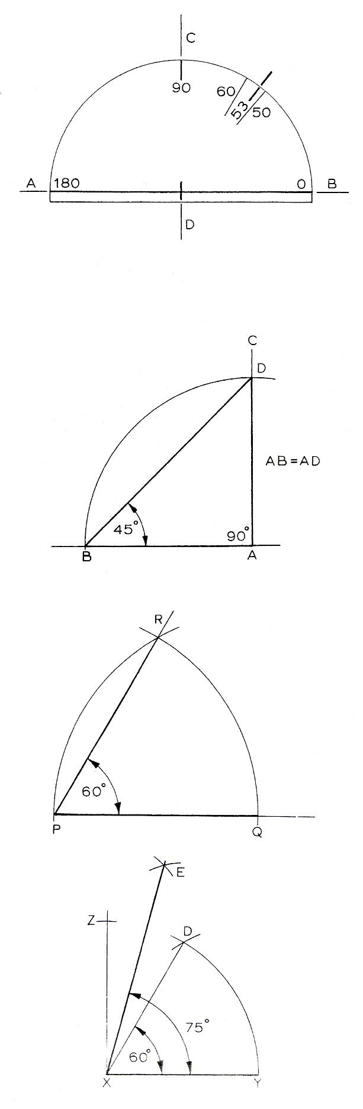
Setting Out Angles With and Without a Protractor
When setting a protractor in position for marking off an angle, care must be taken to line up the base line, i.e. the line marked 180-0, exactly on top of the line on the work from which the angle is being marked.

As check, where possible line up the 90° line on the protractor with a line at right angles to the base line on the work - AB and DC in the illustration.

When marking off, take care to view the gradation on the protractor from directly above to avoid the effect of parallax.

Standard 45° and 30° squares may be so arranged as to give angles in multiples of 15°.

The second illustration shows the construction of a 45° angle. Starting with AB, use A as centre to describe a 90° arc, the radius being AB. AD and AB are at right-angles. The line BD is at 45° to both AB and AD.

The construction of an angle of 60° is given opposite. Starting with PQ, use P as centre to describe an arc having a radius equal to PQ. Keeping exactly the same radius, and with Q as centre, make an arc from P. Let the arcs intersect at R; then PR is at 60° to PQ.

To construct a line at 75° to another the construction in the bottom illustration may be used. XZ and XY are at right-angles. First, construct XD at 60° to XY; then; bisect angle DXZ. Then, angle EXY = 75°.

Hexagons
On this page various methods of constructing hexagons are shown. Although in any diagram the 'corners' may be shown at top and bottom, they could be on a horizontal line. The student will find it useful to try to do this.
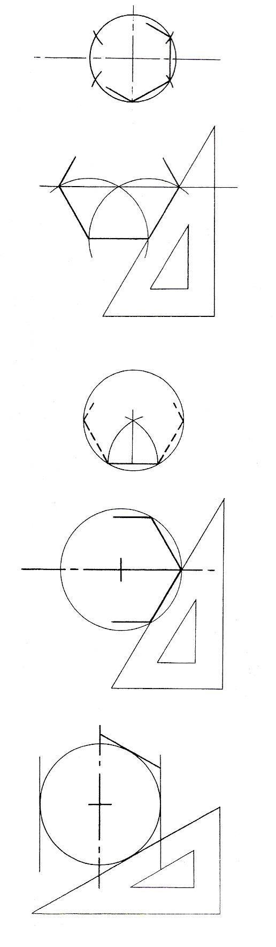
Draw a circle. Keep the compasses set at exactly the same radius and step it out round the circle - it will go six times. Join the points to form the hexagon.

Generally, it is most convenient to start with the horizontal base, but the construction is similar if begun with a vertica1line.

Draw the base line to size. Draw a line at 60° as shown by the square. Measure off this line to size, or swing round an arc as shown. Continue with square and marking off until the hexagon is complete.

In this case the length of the side is given. Draw the 'base' to size. Swing arcs up from the ends of the base. The point of intersection is the centre of a circle whose radius is equal to the length of a side. Draw round the inside of the circle using the 60° square until the hexagon is complete.

The object here is to draw a hexagon inside a circle.
Draw a horizontal diameter across the circle. From one end of this diameter use the 60° square to make the first side of the hexagon. By turning the square over, another side may be drawn from the other end of the diameter. Similarly, all the sides may follow the top and bottom being drawn horizontally.

The hexagon is drawn here on the outside of a circle. The dimension given is A/F, i.e. Across Flats. After drawing the circle simply draw lines, lightly at first, at the appropriate angles to make the hexagon.

Exercises
Draw the triangles where:
- AB = 70, AC = 100, BC = 110 mm.
- AB = 65 mm, AC = 80 mm, angle BAC = 40°.
- AB = 100 mm, angle BAC = 35°, ABC = 72°.
- The sides are 125, 100 and 75 mm.
- AB = 70 mm, AC = BC = 90 mm.
Draw the hexagons where:
- The sides are 40 mm.
- Across corners = 100 mm.
- A/F = 120 mm.
Draw the octagon:
- With sides of 40 mm.
- Where A/F = 100 mm.
- Within an 80 mm diameter circle.
- Construct a circle to pass through points A, B and C, where AB = 70, BC = 40 and AC = 90 mm.
- Construct an 80 mm diameter circle to touch two lines meeting at 130°.

Octagons (Eight-Sided Figures)
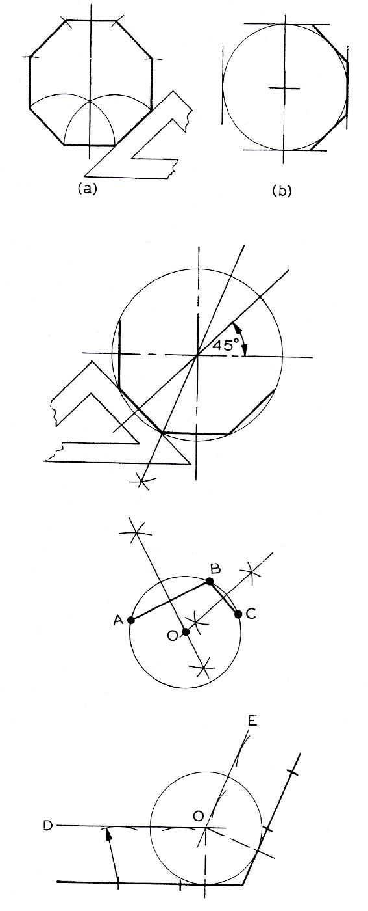
The constructions (a) and (b) are similar to those used for hexagons. In (a), draw one side to size, draw a line at 45°, mark off to size; continue with a vertical line. Proceed until all the sides are drawn.
In (b), with the A/F dimension given, draw the circle of that diameter and with a 45° square complete the polygon.
To draw an octagon within a circle, i.e. having the dimension 'over the corners', start with a diameter (say vertically). Draw a diameter at 45° to the first. Then bisect the 45° angle. This line will cross the circle at a corner of the octagon. Proceed to draw successive lines, using the 45° square, to complete the polygon.

Circles
To construct a circle to pass through three points, the lines joining the points may be considered as chords of the circle.
Construct the perpendicular bisectors of AB and BC. (Equal arcs from each end above and below each line.) The point of intersection of the bisectors is the centre of the circle, O. The radius is OA or OB or OC.
The circle shown left is drawn so as to touch the straight lines.
The lines DO and EO are parallel to the given lines. This is done by making small arcs, with centres on the given lines and radius exactly that of the circle. Draw through the arcs. The intersection gives the centre, O.

Material Removal
Basically, there are two methods of removing metal mechanically:
- Chip forming, i.e. drilling, planning, end milling, sawing.
- Non-chip, forming, i.e. tin snips, shears, punches, croppers, notchers, nibblers and guillotines, all of which employ a form of shearing action.

Shearing (Guillotine)
The principle of shearing is similar to punching except that the area being sheared is a relatively small continuous section, starting at one end of the plate and ending at the other. A hold-down clamping stop holds the plate rigid during cutting in the case of guillotines.
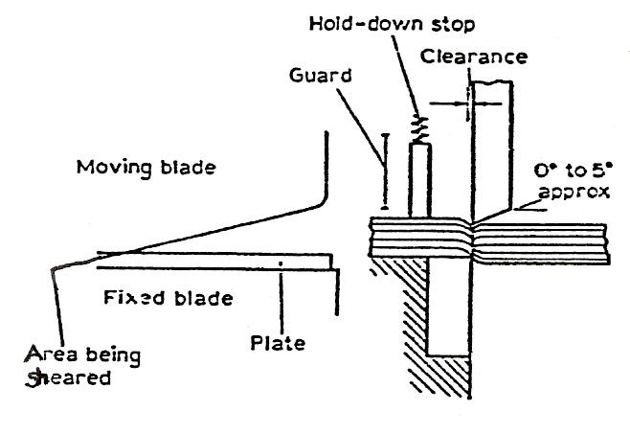
Figure 2 - Guillotine: Principle of Shearing

An important factor in the production of a good cut edge is the clearance between the blades as well as the sharpness of the blade edges. Some machines have provision for altering the blade clearance to suit the thickness of plate being cut out usually the clearance is set at manufacture and checked periodically. A reasonable guide is 0.1 mm increase in clearance for every 1 mm of sheet thickness.

Shears
There are different kinds of shears, both for thin and thick sheet. The following are the most common types, in addition to the guillotine.

- Rotary Shears
- Usually mechanically powered but may be hand operated for thin sheet.
- May have one straight fixed blade and one rotating circular blade (Figure 3)
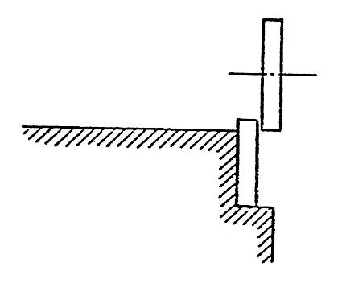
Figure 3 - One Straight Fixed Blade, One Rotating Circular Blade

- May have two rotating circular blades (Figure 4), one at an angle to the other.
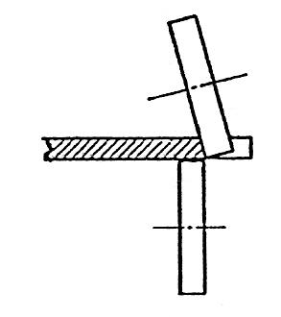
Figure 4 - Two Rotating Circular Blades, One at an Angle to the Other

Guillotine – Steel Stores

Safe Work Practices

Objective:
To cut metal to a suitable size in a safe manner using guillotine.

Personal Protective Equipment:
Overalls, safety boots and gloves (as required).

Procedure:
- Inspect machine to ensure there are no obvious defects and all safety features are in correct working order.
- Measure distance from front of blade to stop.
- Turn on main power supply.
- Turn on ISOLATOR - PRESS GREEN SWITCH.
- Present metal to be cut to blade.
- Press shrouded pedal to activate guillotine.
- When cutting is finished power down and lift up gate at rear to retrieve cut pieces.

Safety Issues
- Ensure all guards are in plate before starting machine.
- Ensure prescribed personal protection is worn.
- Before using guillotine its maximum shearing capacity must be understood.
- Gloves must be worn if there are sharp edges on metal.
- Scrap behind machine to be cleared up daily.

Metal Working Machines

Objective
To cut and punch steel.

Personal Protection
Overalls and safety boots.

Procedure
Inspect machine to ensure there are no obvious defects.
Turn on isolator switch and green start button.
Present the metal to be cut to the cropper, shears or punch as required according to specification.
Ensure hands are clear of cutting action.
Depress shrouded pedal until one cycle operates and metal is sheared.
Remove foot from pedal, remove metal from machine and turn off machine and isolator.

Safety Issues
Only one operator is allowed operate machine at anyone time.
Exercise extreme caution to ensure fingers do not come in contact with punching or shearing action.
Always wear the personal protection provided.
Do not operate machine unless an instructor is present.
Ensure area around machine is free from material which could cause a trip hazard.

Shearing (Guillotine)

The Guillotine
Factors which will affect the guillotine are:
- Blade Clearance
- Rake Angle
- Relief Angle

Blade Clearance
This is the distance between the top blade and the bottom blade. With most machines this distance is adjustable and must be set for each thickness of plate before cutting. If this is not done, twist and excessive burring can occur. Also the plate can get caught in the top blade on the· return stroke and overload the machine.

Rake Angle
This is the angle of the top blade. It is usually 1:8, that is, the blade will lower 10 mm for every 80 mm in length. This will give the lowest shearing force for a given thickness of plate.

Relief Angle
This is the second angle on the top blade. It is usually 1½° to 5° depending on the material being sheared. The softer the material the greater the relief angle.

The Blades
The top blade penetrates about ⅓ the thickness of the plate, the remainder tears off.

Guillotines
Guillotines may be mechanically or hydraulically operated. The plate may be cut by lining up a marked line with the bottom blade or with a shadow line. They usually have one arm fitted with a roller so that one off jobs may be cut square. Where large numbers are required a back stop may be used. This is a bar at the back of the guillotine which may be manually or electrically operated, which when set will give the correct measurement from the blade to the back stop. The guillotine is also fitted with hold down stops, which are timed with the stroke of the blade; they clamp the plate which is to be sheared.
Always make sure that the plate is under the hold down stops.

Safety
- Know where emergency stops are.
- Make sure all guards are in position.
- Never remove guards.
- Make sure nobody is at the rear of the guillotine.

The Principle of Shearing
The principle of shearing is:
The area being sheared is an all continuous section, starting at one end of the plate and ending at the other.

A hold-down clamping stop holds the plate rigid during cutting.

An important factor in the production of a good cut edge is the clearance between the blades as well as the sharpness of the blade edge.

Some machines have provision for altering the blade clearance to suit the thickness of plate being cut, but usually the clearance is set at manufacture and checked periodically.

A reasonable guide is 0.1 mm increase in clearance for every 1 mm of sheet thickness.

Self Assessment

Questions on Background Notes – Module 1.Unit 5

1. When using a Pedestal Drill, list two pieces of P.P.E (Personal Protective
Equipment) to be worn.

2. With the aid of a diagram sketch an R.S.C.

- Sketch and clearly show the following:
a. U.C
b. The Flange
c. The Web

4. When drilling and tapping, to successfully tap a hole, three taps are required, name
them.

5. In relation to tapping and drilling, what is a blind hole?

6. When sharpening a drill bit and establishing the cutting edge, list two important
points.

7. When holding work for drilling, list one of the methods of clamping the work.

8. Briefly explain counter boring a hole.

9. What are reamers used for?

10. Give one advantage of using cutting fluids / coolants.

Answers to Questions 1-10. Module 1.Unit 5

1.

Safety Boots / Safety Specs.

2.

Figure 5. (R.S.C)

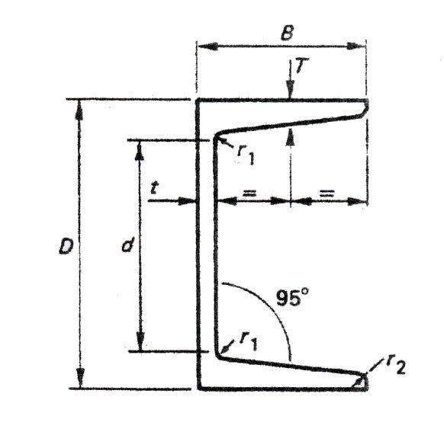

3.

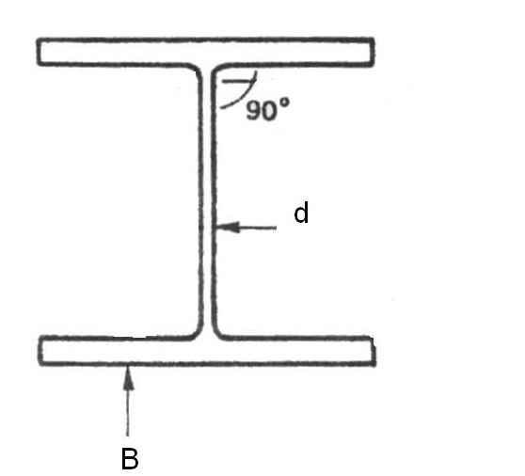
Figure 6. (U.C)

B = Flange
d = Web

4.

1. Taper Tap.

2. Secondary or Intermediate Tap.

3. Plug Tap

5.

A hole that is not drilled fully through.

6.

1. Hold the drill level, twist until one cutting edge is horizontal
and parallel to the wheel face.

2. Position yourself so that the drill makes an angle of approx 60°
to wheel face.

7.

Table Vice

8.

Increasing the hole diameter to a certain depth to accommodate
the head of an allen bolt or cheese head screw.

9.

Used for finishing holes smoothly and accurately. Or enlarging
an existing hole.

10.

To pro-long the life of the cutting tool, also to assist with drilling.

Index

A
Angles, 11
Setting Out Angles With or Without a Protractor, 11
C
Circles, 14
Cleaning, 9
G
Guillotine – Steel Stores, 17
Safe Work Practices, 17
H
Hexagons, 12
Exercises, 13
Hydraulic System, 9
M
Material Removal, 15
Shearing (Guillotine), 15
Shears, 16
Metal Working Machines, 18
Objective, 18
Personal Protection, 18
Procedure, 18
Safety Issues, 18
O
Octagons (Eight-Sided Figures), 14
P
Plane Figures, 10
Parallelogram, 10
Squares and Rectangles, 10
Traingles, 10
S
Safe Work Practices
Objective, 17
Personal Protective Equipment, 17
Procedure, 17
Safety Issues, 17
Section Tooling – General Guides, 9
Shear Tooling – General Guides, 8
Shearing (Guillotine), 19
Blade Clearance, 19
Guillotines, 19
Rake Angle, 19
Relief Angle, 19
Safety, 20
The Blades, 19
The Guillotine, 19
The Principle of Shearing, 20

